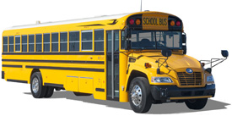
Trip #___________________

Lynchburg-Clay Trip Ticket

A. To be Completed by Sponsor

Today’s date ######### Date of Trip #########

Pick up location: Elementary, Middle School, High School, other ###########

Departure time ######### Return time #########
Destination ################################ ____ ____

Number of students ###### Organization ################ Purpose of Trip #############

Sponsor ############## ____Curricular ____Extra-curricular

B. To be Completed by Principal and Designee

Date ############## Principal ###########################

Date ############## Designee’s Approval #################

C. To be Completed by Driver
Bus number ______ Driver____________________________

D. To be completed by Driver and Sponsor

Sponsor __________________________ Driver ____________________________

E. Payroll Only

Date______________ ______ Hours @ $________ = $__________ Account #____________________

Ending Mileage |  | Departure Time |  | Driving as Coach/Advisor? Y N
Beginning Mileage |  | Return Time |  | Driving: Van Bus
Total Mileage |  | Total Time |  | Time Driven to:
 |  |  |  | Time Driven back:

DOCK TIME (in minutes) ____________________

